# 任务单SimpleAdapter

## 任务一

**设置图书信息列表视图，每个列表项左边显示图书的名称，右边显示图书的价格，其中书名字号大小为20sp，价格采用默认大小。列表项之间保留适当间距。如下图所示。**

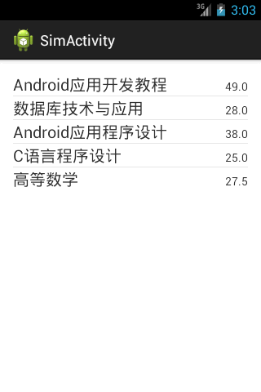

## 任务二

**模仿qq好友列表完成如下图右所示的列表视图。头像大小为80dp*80dp，头像与文字信息之间保留10dp的间距；好友昵称颜色为#cc0000，字号大小为20sp；个性签名颜色为#003399，采用默认字号大小；各列表项上、下均保留5dp的间距。**

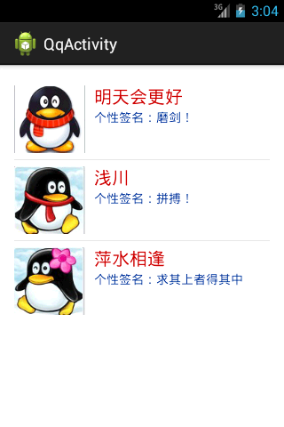

**=======提交规范=======**

**提交word文档，包括布局代码、功能实现代码及运行效果图。**

**截图：**

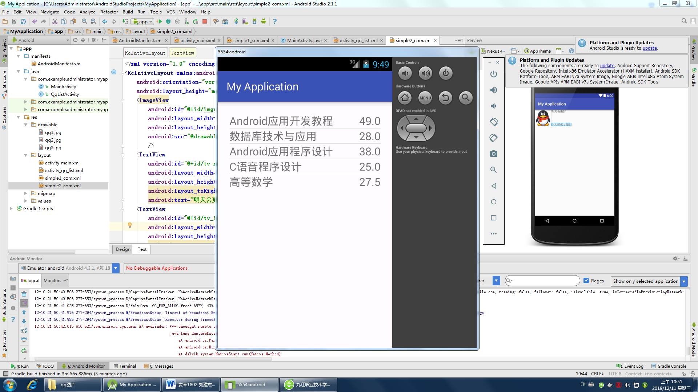

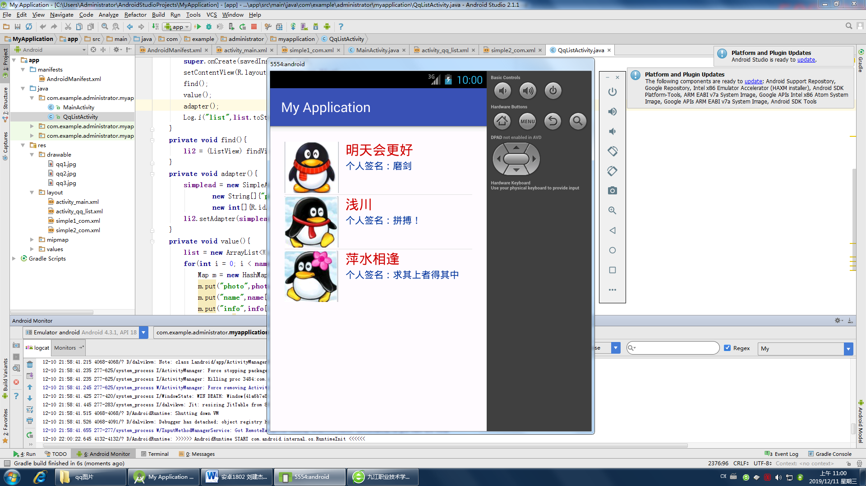

**任务1：**

**Java源程序**

**package** com.example.administrator.myapplication;  
  
**import** android.support.v7.app.AppCompatActivity;  
**import** android.os.Bundle;  
**import** android.util.Log;  
**import** android.widget.ListView;  
**import** android.widget.SimpleAdapter;  
**import** java.util.*;  
  
**public class** MainActivity **extends** AppCompatActivity {  
  
 **private** ListView **li1**;  
  
 **private** SimpleAdapter **simplead**;  
  
 **private** List<Map<String,String>> **list**;  
 **private** String **name**[] ={**"Android应用开发教程"**,**"数据库技术与应用"**,**"Android应用程序设计"**,**"C语音程序设计"**,**"高等数学"**};  
 **private** String **score**[] ={**"49.0"**,**"28.0"**,**"38.0"**,**"25.0"**,**"27.5"**};  
  
 @Override  
 **protected void** onCreate(Bundle savedInstanceState) {  
 **super**.onCreate(savedInstanceState);  
 setContentView(R.layout.***activity_main***);  
 find();  
 value();  
 adapter();  
 }  
 **private void** find(){  
 **li1** = (ListView) findViewById(R.id.***listview1***);  
 }  
 **private void** adapter(){  
 **simplead** = **new** SimpleAdapter(**this**,**list**, R.layout.***simple1_com***,  
 **new** String[]{**"name"**,**"score"**},  
 **new int**[]{R.id.***name***,R.id.***score***});  
 **li1**.setAdapter(**simplead**);  
 }  
 **private void** value(){  
 **list** = **new** ArrayList<Map<String, String>>();  
 **for**(**int** i = 0; i < **name**.**length**; i++){  
 Map m = **new** HashMap();  
 m.put(**"name"**,**name**[i]);  
 m.put(**"score"**,**score**[i]);  
 **list**.add(m);  
 }  
 }  
}

**activity_main.xml**

*<?***xml version="1.0" encoding="utf-8"***?>*<**RelativeLayout  
 xmlns:android="http://schemas.android.com/apk/res/android"  
 xmlns:tools="http://schemas.android.com/tools"  
 android:layout_width="match_parent"  
 android:layout_height="match_parent"  
 android:paddingLeft="@dimen/activity_horizontal_margin"  
 android:paddingRight="@dimen/activity_horizontal_margin"  
 android:paddingTop="@dimen/activity_vertical_margin"  
 android:paddingBottom="@dimen/activity_vertical_margin"  
 tools:context="com.example.administrator.myapplication.MainActivity"**>  
  
 <**ListView  
 android:id="@+id/listview1"  
 android:text="Hello World!"  
 android:layout_width="wrap_content"  
 android:layout_height="wrap_content"  
 android:padding="5dp"**/>  
</**RelativeLayout**>

**simple1_com.xml**

*<?***xml version="1.0" encoding="utf-8"***?>*<**RelativeLayout xmlns:android="http://schemas.android.com/apk/res/android"  
 android:orientation="vertical" android:layout_width="match_parent"  
 android:layout_height="match_parent"**>  
 <**TextView  
 android:id="@+id/name"  
 android:layout_width="wrap_content"  
 android:layout_height="wrap_content"  
 android:text="数学"  
 android:layout_alignParentLeft="true"  
 android:textSize="20sp"**/>  
 <**TextView  
 android:id="@+id/score"  
 android:layout_width="wrap_content"  
 android:layout_height="wrap_content"  
 android:text="60"  
 android:layout_alignParentRight="true"  
 android:textSize="20sp"**/>  
</**RelativeLayout**>

**任务2：**

**Java源程序：**

**package** com.example.administrator.myapplication;  
  
**import** android.support.v7.app.AppCompatActivity;  
**import** android.os.Bundle;  
**import** android.util.Log;  
**import** android.widget.ListView;  
**import** android.widget.SimpleAdapter;  
  
**import** java.util.ArrayList;  
**import** java.util.HashMap;  
**import** java.util.List;  
**import** java.util.Map;  
  
**public class** QqListActivity **extends** AppCompatActivity {  
 **private** ListView **li2**;  
 **private** List<Map<String,Object>> **list**;  
 **private** SimpleAdapter **simplead**;  
  
 **private int photo**[] = {R.drawable.***qq1***,R.drawable.***qq2***,R.drawable.***qq3***};  
 **private** String **name**[] ={**"明天会更好"**,**"浅川"**,**"萍水相逢"**};  
 **private** String **info**[] ={**"个人签名：磨剑"**,**"个人签名：拼搏！"**,**"个人签名：求其上者得其中"**};  
 @Override  
 **protected void** onCreate(Bundle savedInstanceState) {  
 **super**.onCreate(savedInstanceState);  
 setContentView(R.layout.***activity_qq_list***);  
 find();  
 value();  
 adapter();  
 Log.*i*(**"list"**,**list**.toString());  
 }  
 **private void** find(){  
 **li2** = (ListView) findViewById(R.id.***listview2***);  
 }  
 **private void** adapter(){  
 **simplead** = **new** SimpleAdapter(**this**,**list**, R.layout.***simple2_com***,  
 **new** String[]{**"photo"**,**"name"**,**"info"**},  
 **new int**[]{R.id.***imgv_photo***,R.id.***tv_name***,R.id.***tv_info***});  
 **li2**.setAdapter(**simplead**);  
 }  
 **private void** value(){  
 **list** = **new** ArrayList<Map<String, Object>>();  
 **for**(**int** i = 0; i < **name**.**length**; i++){  
 Map m = **new** HashMap();  
 m.put(**"photo"**,**photo**[i]);  
 m.put(**"name"**,**name**[i]);  
 m.put(**"info"**,**info**[i]);  
 **list**.add(m);  
 }  
 }  
}

**activity_qq_list.xml**

*<?***xml version="1.0" encoding="utf-8"***?>*<**RelativeLayout xmlns:android="http://schemas.android.com/apk/res/android"  
 xmlns:tools="http://schemas.android.com/tools"  
 android:layout_width="match_parent"  
 android:layout_height="match_parent"  
 android:paddingBottom="@dimen/activity_vertical_margin"  
 android:paddingLeft="@dimen/activity_horizontal_margin"  
 android:paddingRight="@dimen/activity_horizontal_margin"  
 android:paddingTop="@dimen/activity_vertical_margin"  
 tools:context="com.example.administrator.myapplication.QqListActivity"**>  
 <**ListView  
 android:id="@+id/listview2"  
 android:text="Hello World!"  
 android:layout_width="wrap_content"  
 android:layout_height="wrap_content"  
 android:padding="5dp"**/>  
</**RelativeLayout**>

**Simple2_com.xml**

*<?***xml version="1.0" encoding="utf-8"***?>*<**RelativeLayout xmlns:android="http://schemas.android.com/apk/res/android"  
 android:orientation="vertical" android:layout_width="match_parent"  
 android:layout_height="match_parent"**>  
 <**ImageView  
 android:id="@+id/imgv_photo"  
 android:layout_width="80dp"  
 android:layout_height="80dp"  
 android:src="@drawable/qq1"** />  
 <**TextView  
 android:id="@+id/tv_name"  
 android:layout_width="wrap_content"  
 android:layout_height="wrap_content"  
 android:layout_toRightOf="@id/imgv_photo"  
 android:text="明天会更好"  
 android:textSize="20sp"  
 android:textColor="#cc0000"  
 android:layout_marginLeft="10dp"**/>  
 <**TextView  
 android:id="@+id/tv_info"  
 android:layout_width="wrap_content"  
 android:layout_height="wrap_content"  
 android:layout_alignLeft="@id/tv_name"  
 android:layout_below="@id/tv_name"  
 android:textColor="#003399"  
 android:text="个人签名：魔剑"**/>  
</**RelativeLayout**>